/[\+][994]+[50?1?5 70?7]+[0-999]+/gm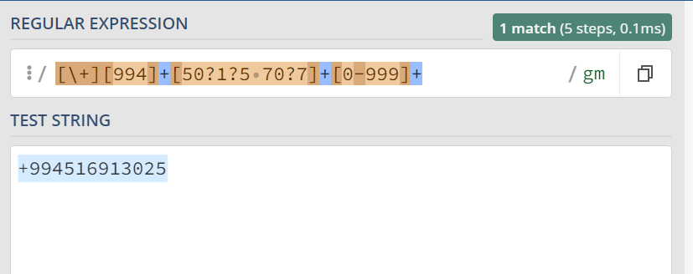

^(0[1-9]|1[0-9]|2[0-9]|3[0-1])[-\.\/](0[1-9]|1[012])[-\.\/](200[0-9]|201[0-19]|202[0-22])$ date

https://regex101.com/r/NyWSkc/1